CS 340 README Template

About the Project/Project Title
The Python application has a primary goal of giving a user the ability to access a database of animals. Within this database, the user can filter categories to easily access specified data. A dashboard will be presented with the filtered information including a pie chart and a geolocation map.

Motivation
The motivation behind this project is to learn how to apply successful methods for a web application that connects a client-side user interface to a database. It will help to develop a portable python module that enables CRUD functionality for this data connection. Once successful integration is established, the dashboard presents skills in creating and implementing working filters and varying data representation.

Getting Started
To get a local copy up and running, follow these simple example steps:

Installation
Python
MongoShell
PyMongo driver
Codio

Usage
Use this space to show useful examples of how your project works and how it can be used. Be sure to include examples of your code, tests, and screenshots.

Code Example
By running the program, the dashboard is presented. From here, you can find the radio buttons titled “Water Rescue, Mountain Rescue, Disaster Rescue and reset”. Upon selection, the data will update in real-time to filter and sort based on the selected button. Beneath the table you will find a pie chart as well as a geolocation map that reflects the individual animals location and details when selected. The Grazioso Salvare image is always maintained at the top of the dashboard.

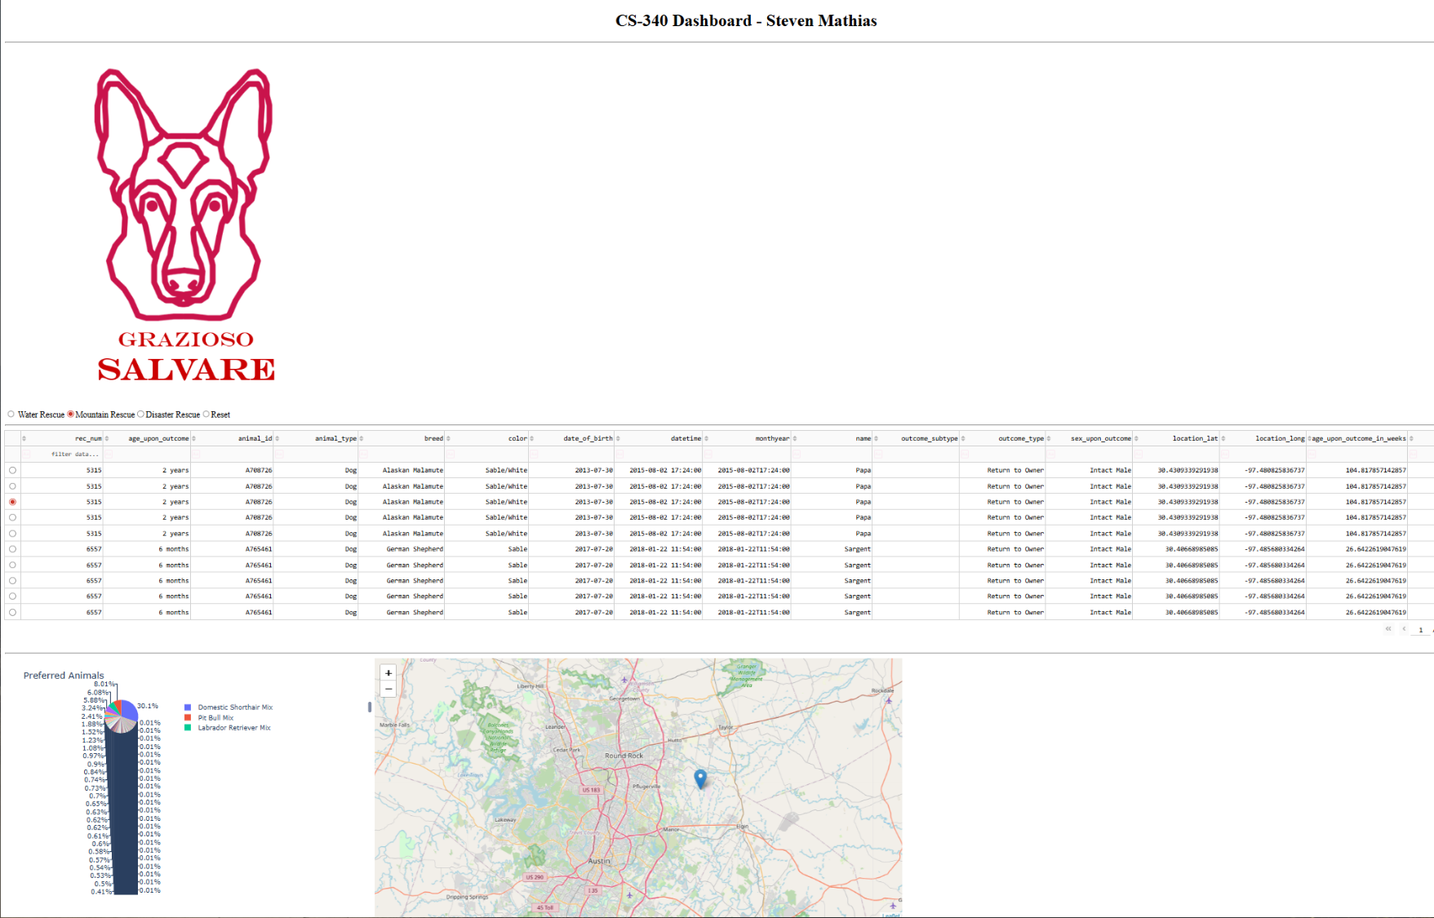
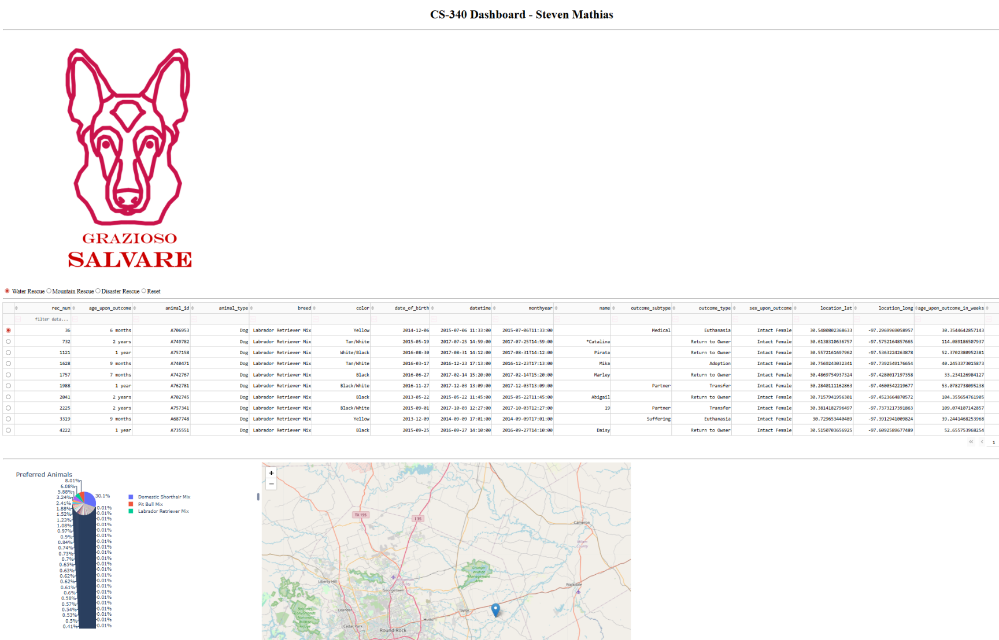
Screenshots
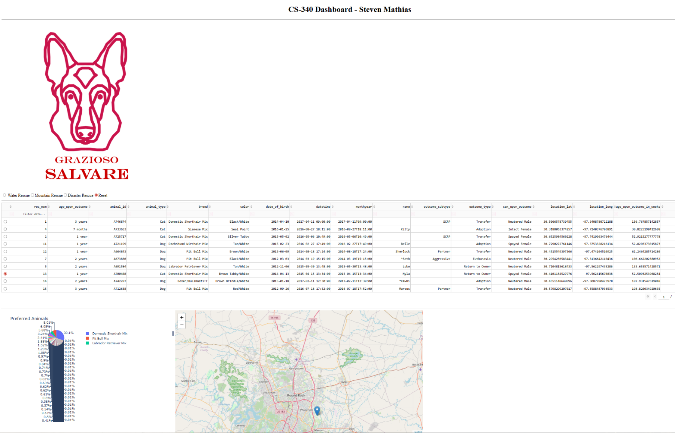
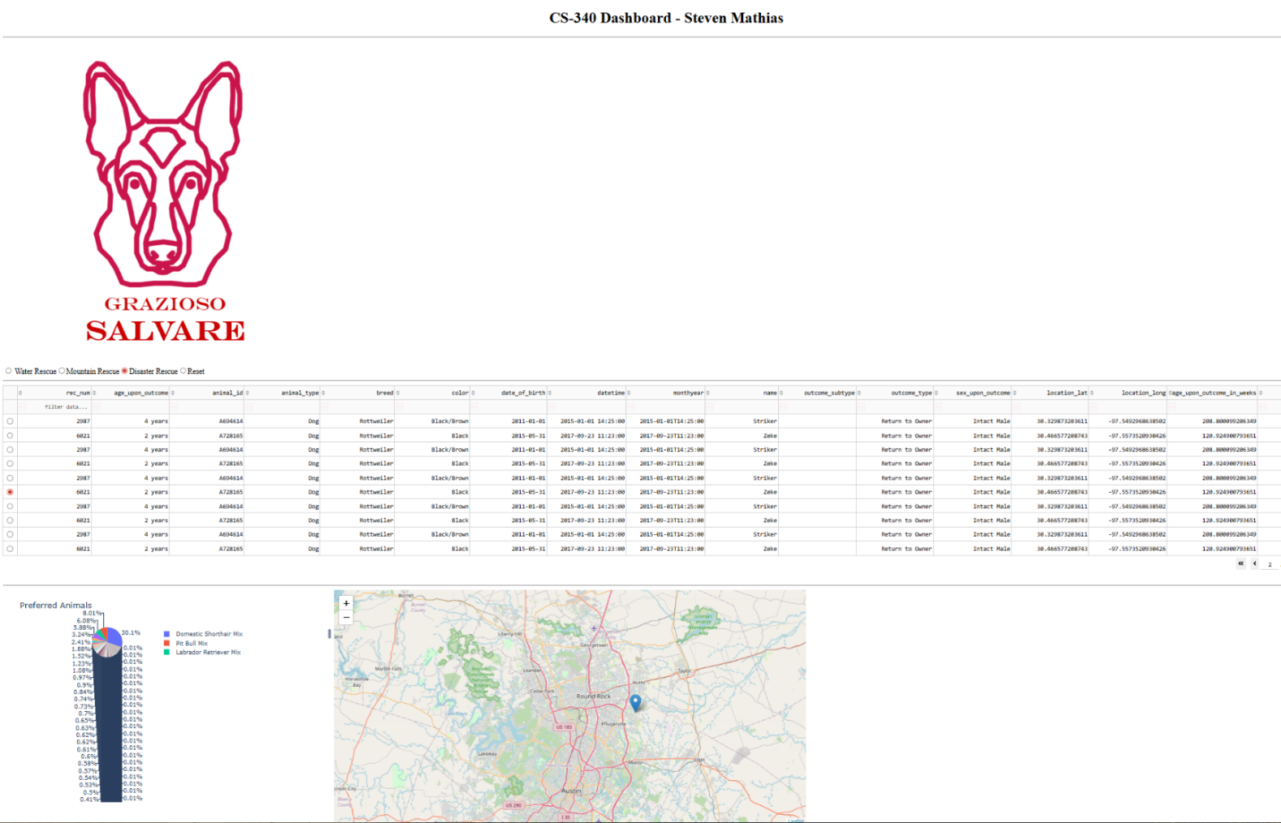

Contact
Your name: Steven Mathias

